PowerShell Scripting and Configuration
Introduction
This assignment focused on learning PowerShell scripting and configuration within a Windows environment. The lab covered PowerShell profile customization, script creation, parameter implementation, input validation, error handling, and business logic integration.
Profile Setup and Customization
A PowerShell session was started, and the current profile settings were viewed using:
$PROFILE | Select-Object *
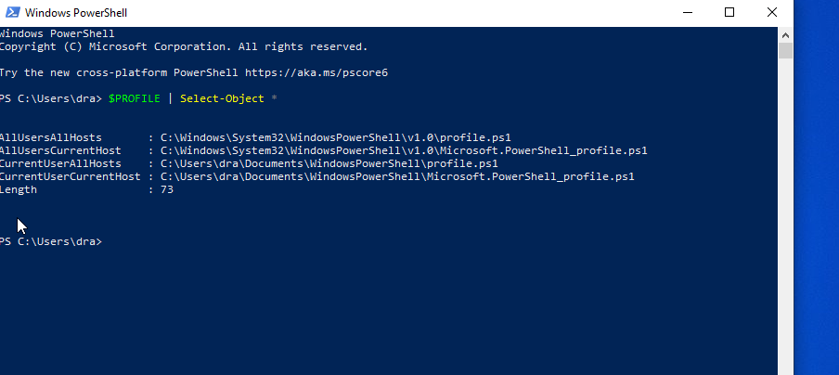

A custom PowerShell profile was created using:
New-Item -Path $PROFILE -ItemType File -Force
A personalized greeting message was added to the profile. The execution policy was configured using:
Set-ExecutionPolicy -Scope CurrentUser -ExecutionPolicy RemoteSigned
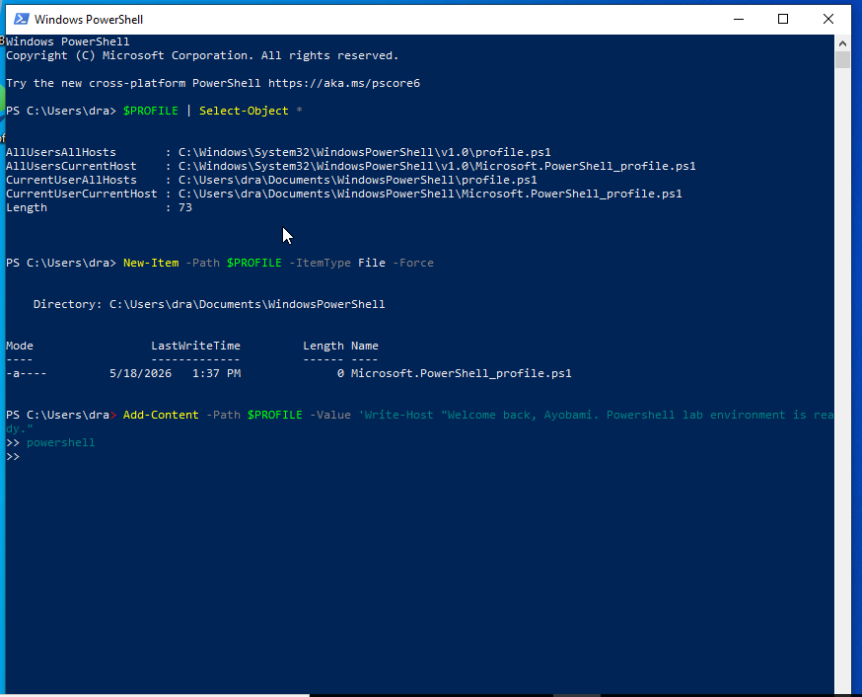
Creating and Executing a Script
A script named Backup.ps1 was created inside the C:\Powershelllab directory. Parameters for source and destination paths were implemented to support backup operations.
The script successfully copied files and folders from the source directory to the destination directory using:
Copy-Item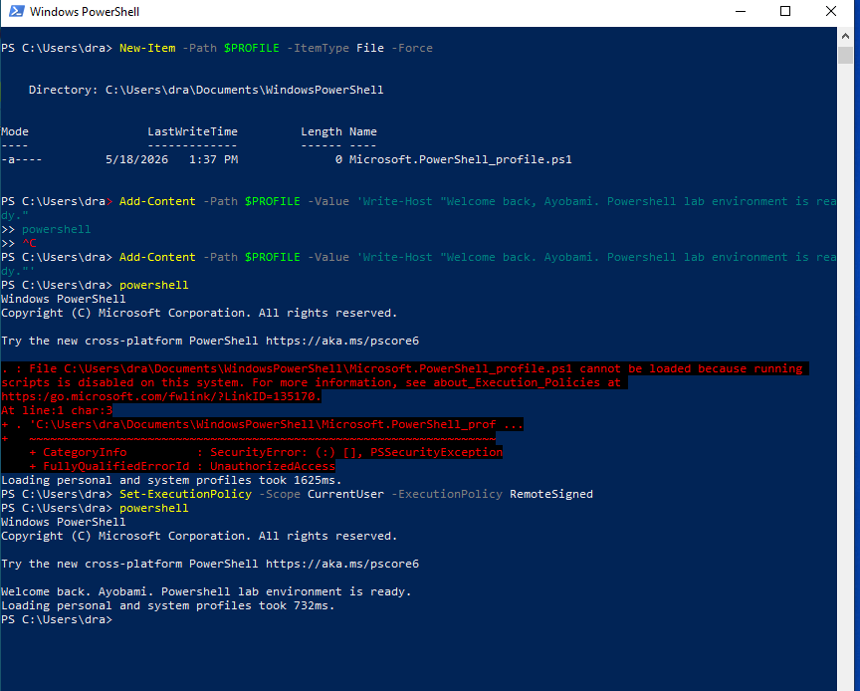
Input Validation and Error Handling
Input validation logic was added to improve script reliability. The script checked whether the source directory existed before performing backup operations. Troubleshooting and debugging were also performed to resolve syntax and execution policy issues encountered during testing.
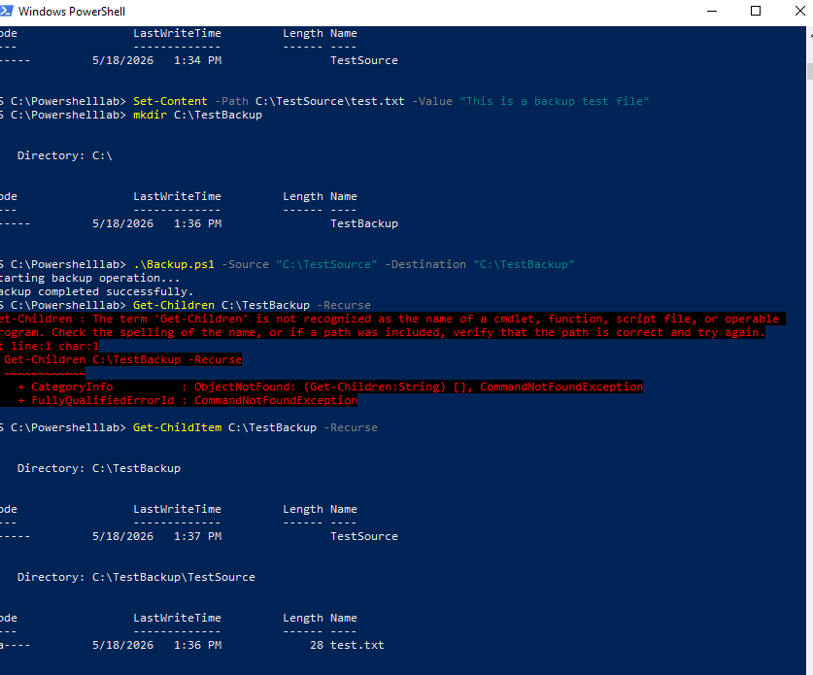

Implementing Business Logic
A switch parameter named -WebApp was implemented to identify web application content. The script checked for .html, .js, and .css files within the source directory.
Testing was performed using sample web application files such as index.html.
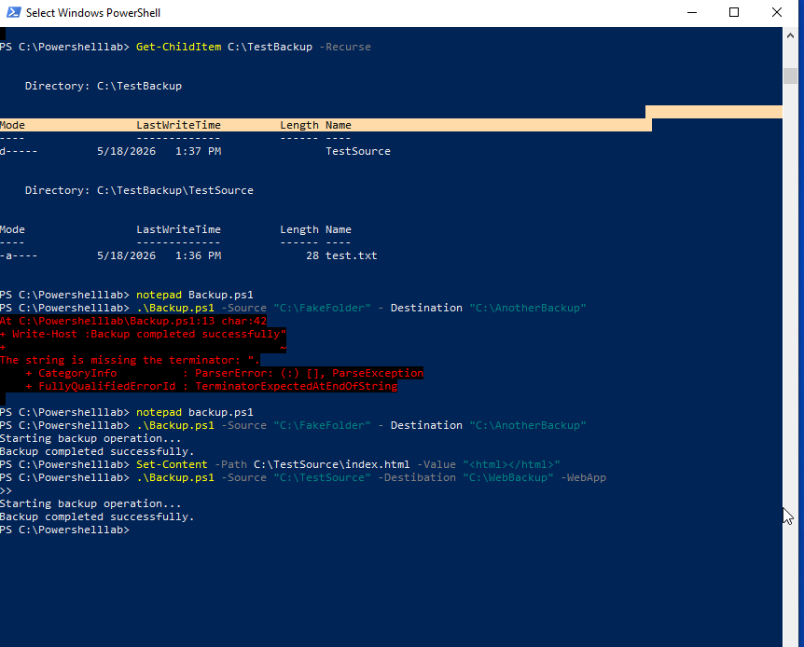

Key Learnings

- How PowerShell profiles work
- How to configure execution policies
- How to create and execute PowerShell scripts
- How to implement parameters and switch parameters
- How to perform file backup operations
- How to implement input validation and troubleshooting
- How to integrate business logic into PowerShell scripts
Conclusion
This assignment provided practical experience in PowerShell scripting and configuration. It improved my understanding of automation, script management, debugging, and administrative scripting tasks in Windows environments.

